Request for a Transcript or Digital Copy of an Audio Recording

- Log into ECF
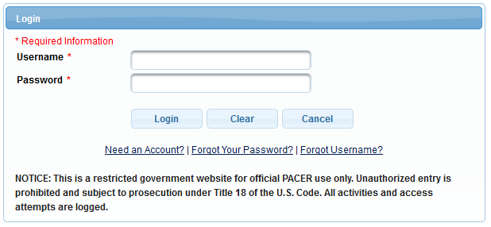

- Select the appropriate case type, Civil or Criminal, for which you would like a transcript.

- Select Other Documents under the Other Filings Category
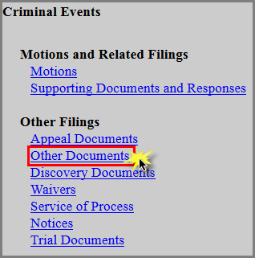
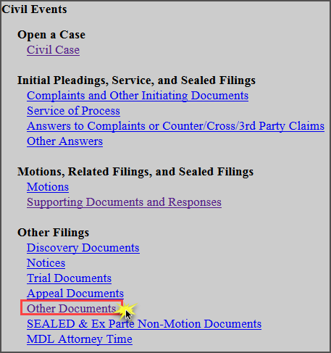

- Enter the case number and click Find Case. Select the appropriate case and click Next. In criminal cases, be sure to select the correct defendant(s).

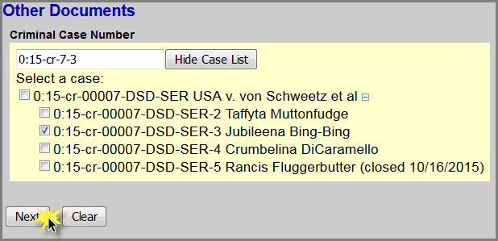
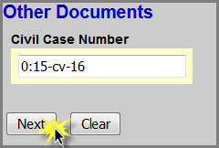

- Click Next
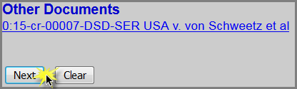

- Select Transcript/Copy Request from a Digital Audio Recording as the Event and select the filer.
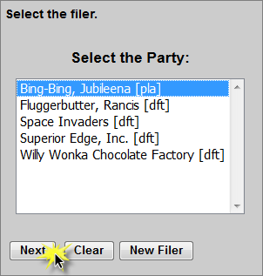
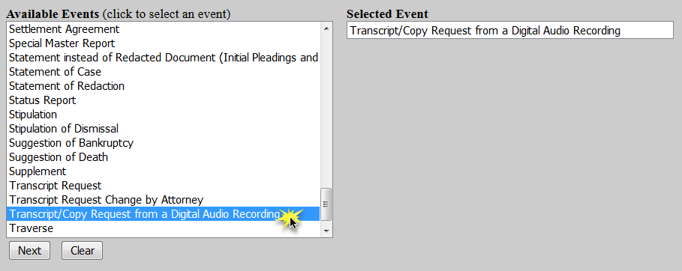

- For criminal cases only, confirm the correct defendant(s) has been selected. SKIP this step for civil cases.
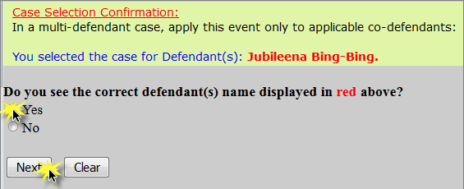

- Select if you would like a transcript of the audio recording or a copy of the digital audio recording itself and click Next.
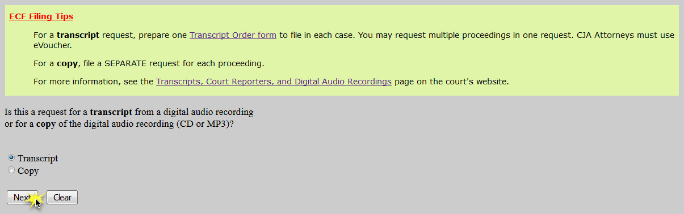

Transcript:

  - Complete the Transcript Order Form and convert/print it to PDF

  - Select whether the proceeding was open or sealed and click Next.
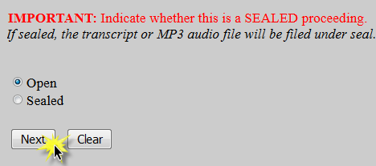

  - Click Browse to attach the completed Transcript Order Form as the Main Document and click Next.
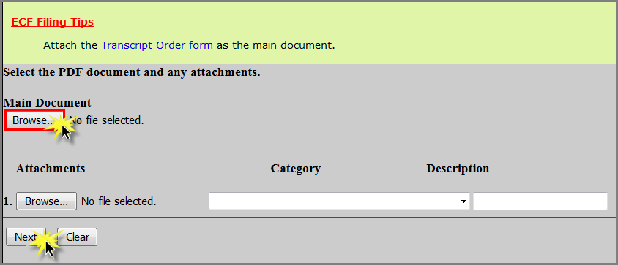

  - Select the delivery type and click Next.
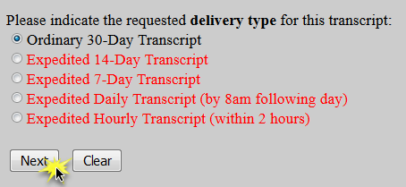

  - Click Next.

  - Ensure all information is accurate and click Next to finalize the request.
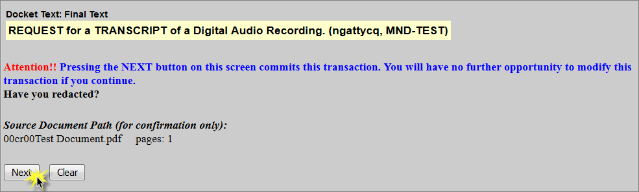

  - A Notice of Electronic Filing screen will appear to confirm the request was successful.
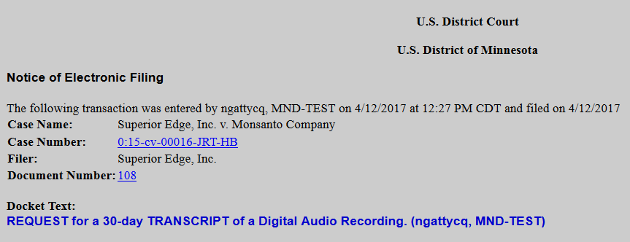

Digital Copy:
- Select whether the proceeding was open or sealed and click Next.
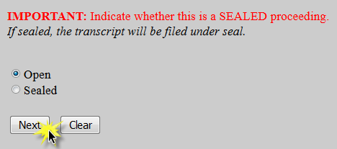

- Select Minute Entry for the proceeding for which you would like a transcript and click Next.
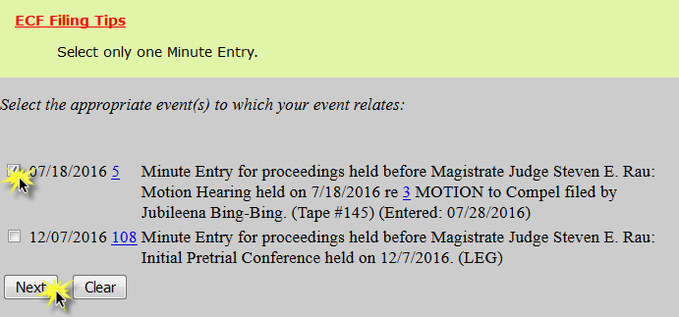

- Enter the details of the proceeding you selected and click Next.
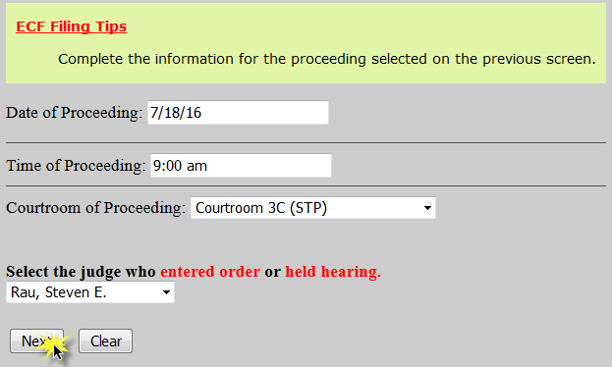

- Click Next

- Select whether the filing is on behalf of the U.S. or the Federal Defender’s Office and click Next.
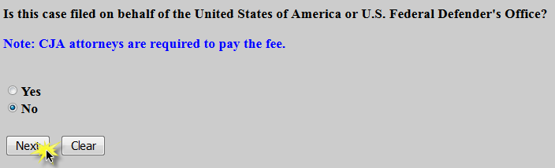

  - If the filing is NOT on behalf of the U.S. or the Federal Defender’s Office, follow steps f-j below to provide payment.

  - If the filing is on behalf of the U.S. or the Federal Defender’s Office, confirm by clicking Next. Then SKIP to step j below.
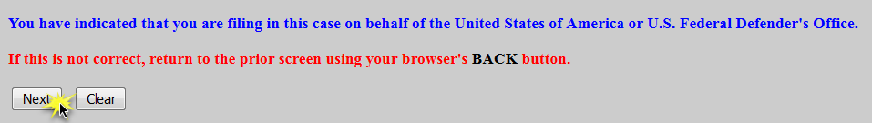

- Read the payment information screen and click Next.

- If prompted, re-enter your password.

- Select a payment method and click Next.
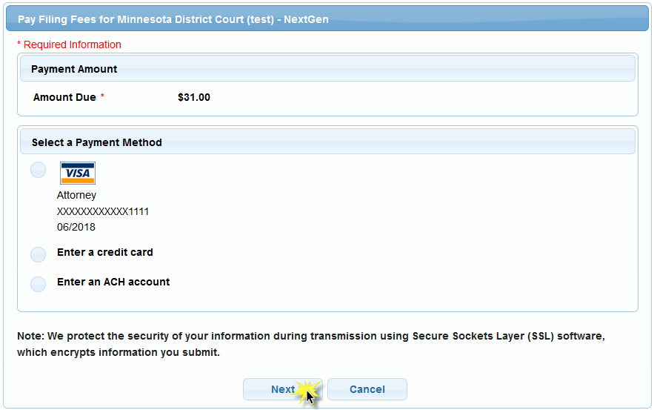

- Complete all payment screens. Check the authorization box and click Submit.
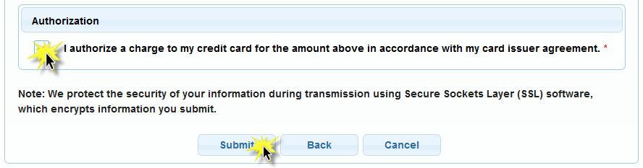

- If the requester of the transcript is the filing attorney, the fields on this screen may be left blank. If the requester is not the filing attorney (i.e. an assistant to the attorney) enter the Requester’s information and click Next.
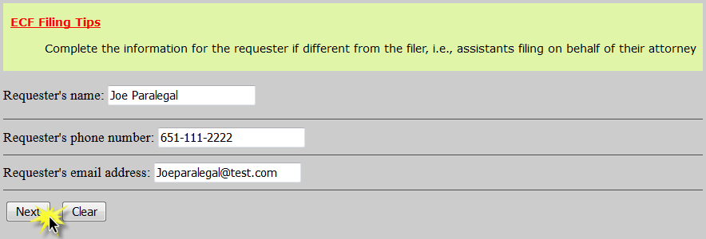

- Select the desired format of the audio file (CD or MP3) and click Next.
NOTE: CD’s will be mailed to the address listed on the docket for the filer. Any changes to the recipient should be noted in the special requests text box on this screen.
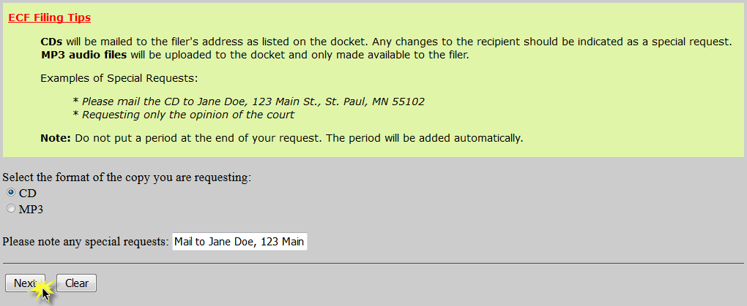

- Click Next.

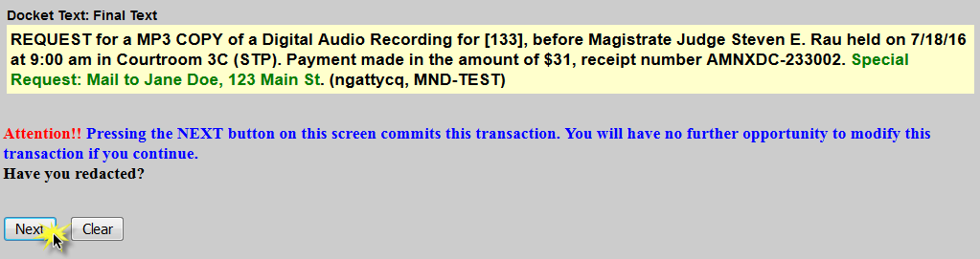
- Ensure all information is accurate and click Next to finalize the request.

- A Notice of Electronic Filing screen will appear to confirm the request was successful.
