Inactive Attorney Re-Registration Procedure
Click here to check if you are inactive with the U.S. District Court, District of Minnesota.

- Log into ECF. You can access ECF by navigating to our website. Then, select Case Information and Electronic Case Filing.
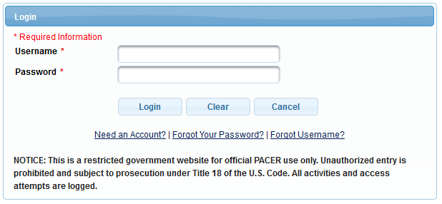

** If you do not see the Civil and Criminal options on the top menu (as illustrated below), your account is not up to date and you need to follow the additional instructions on page 4 of this procedure before continuing.

- Click on Utilities.

- Select Inactive Attorney Re-Registration under the Attorneys category.
**If you do not see the Inactive Attorney Re-Registration option on this screen, your account is not up to date and you need to follow the additional instructions on page 4 of this procedure before continuing.
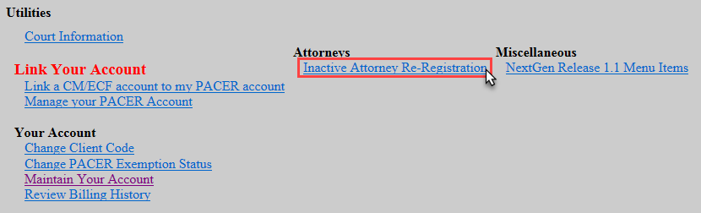

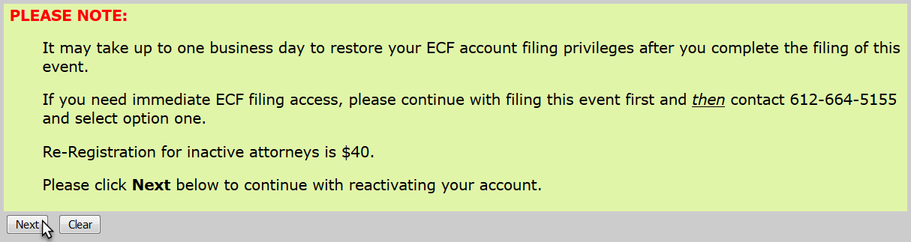
- Read the ECF Filing Note and click Next.

- Click Next.

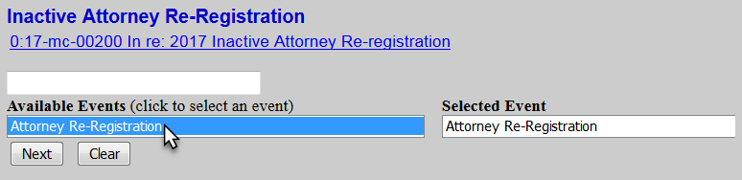
- Select Attorney Re-Registration and click Next.

- Check the box to confirm that you have verified and, if necessary, updated your ECF attorney information and click Next.
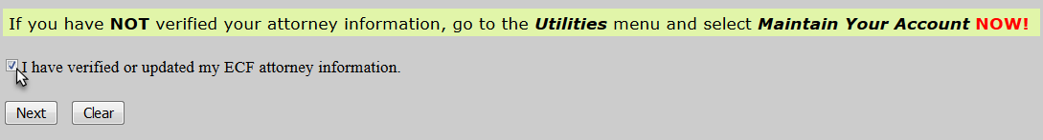

- Select whether or not you are a U.S. Government Attorney and click Next.
Note: If you are a U.S. Government Attorney, please skip to Step 13
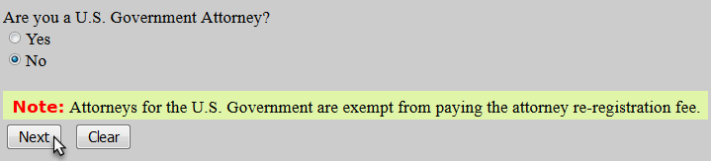

- Note the payment amount and information and click Next.
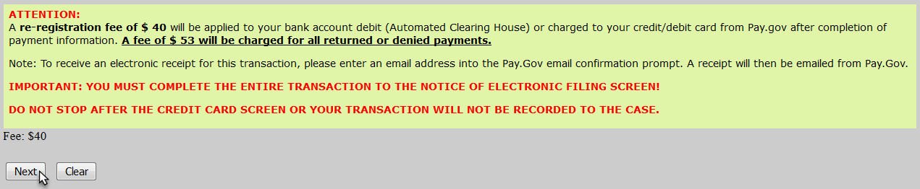

- ECF will temporarily route you to PACER’s website for the collection of fees. Select a Payment Method and click Next.
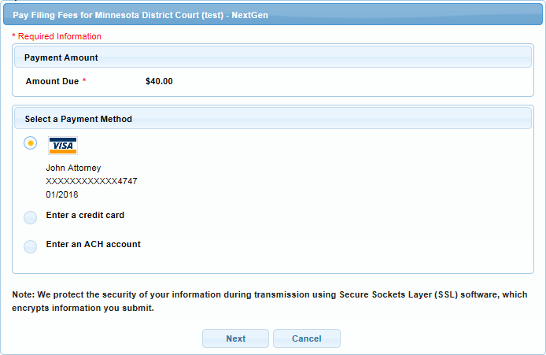

- Enter all required payment information, check the payment authorization box, and click Submit.

- Click Next.

- Read the ECF Filing Note and click Next.
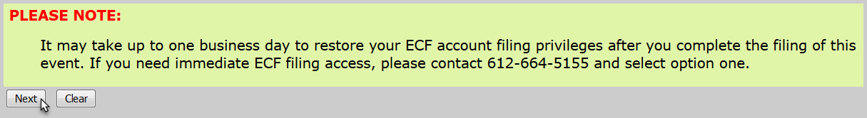

- Click Next.

- Ensure all information is accurate and click Next to finalize the filing.
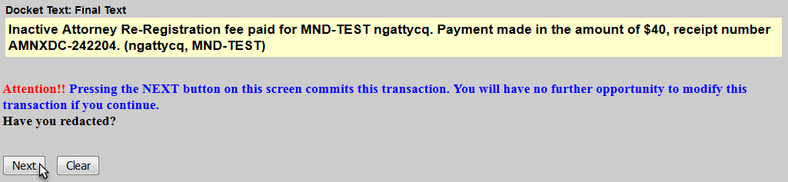

- A Notice of Electronic Filing screen will appear to confirm the filing was successful.
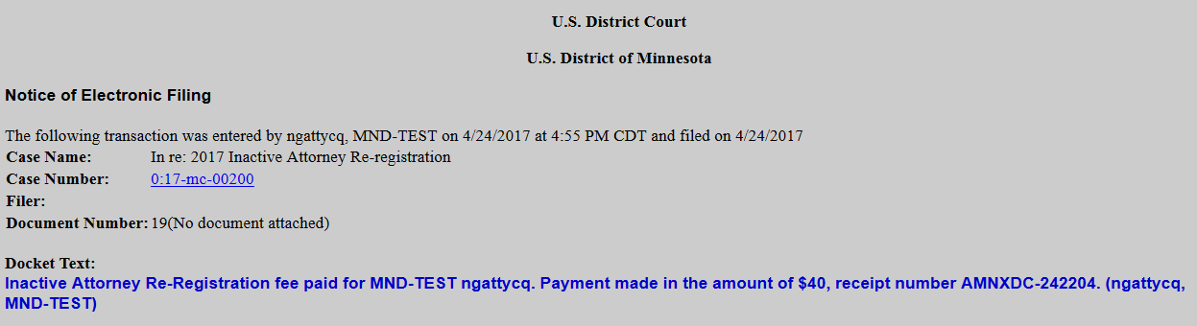

Additional Procedures Only for Accounts
That Are Not Up to Date

** If you do not see the Civil and Criminal options on the top menu, or do not have the Inactive Attorney Re-registration option under the Utilities menu, your account is not up to date and you need to follow these additional procedures prior to completing the Inactive Re-Registering procedure.
In order to file in the U.S. District Court for the District of Minnesota, e-filers must:
- Have an upgraded individual PACER account. A shared firm account cannot be used.
- Link your upgraded individual PACER account to your ECF Account
- The linking process requires users to enter their current ECF username (usually your MN Bar ID without leading zeros) and password. If you do not know your password, please click here to use the password reset system.
- Click here for procedures to acquire a new individual PACER account.
- Click here for procedures to upgrade your current PACER account.
- Click here for procedures to link your upgraded individual PACER account to your ECF Account.

Click here for further information on our website.
For further assistance, call the ECF Helpdesk at 612-664-5155 or 866-325-4975.

