Transcript Request

- Complete the Transcript Order Form and convert/print it to PDF.

- Log into ECF.
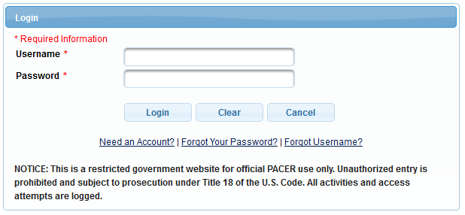

- Select the appropriate case type, Civil or Criminal, for which you would like a transcript.

- Select Other Documents under the Other Filings Category.
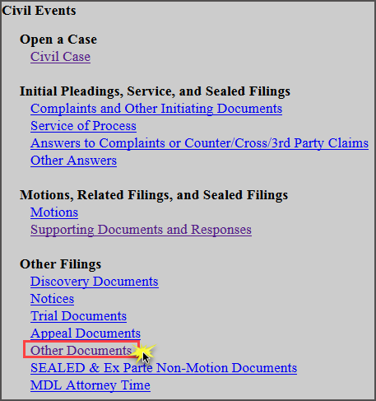
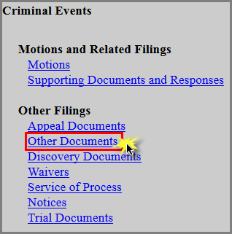

- Enter the case number and click Find Case. Select the appropriate case and click Next. In criminal cases, be sure to select the correct defendant(s).

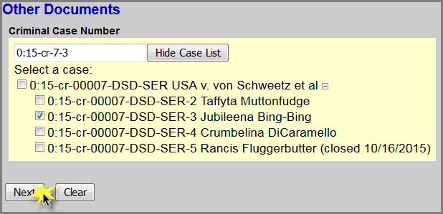
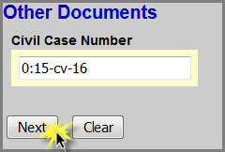

- Click Next.
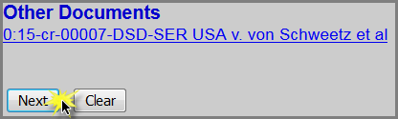

- Select Transcript Request as the Event and select the filer.
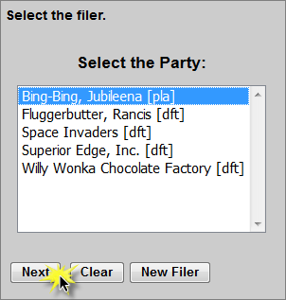
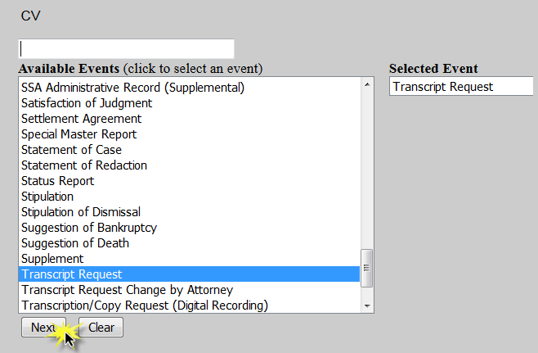

- For criminal cases only, confirm the correct defendant(s) have been selected. SKIP this step for civil cases.
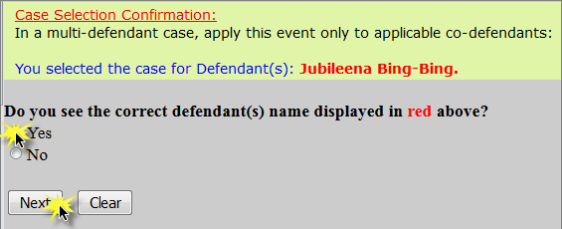

- Read the Filing Tip and click Next.

- Select the type of request and click Next.
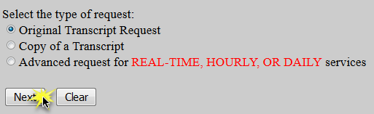

Original Transcript Request:
a. Click Browse to attach the completed Transcript Order Form as the Main Document and click Next.
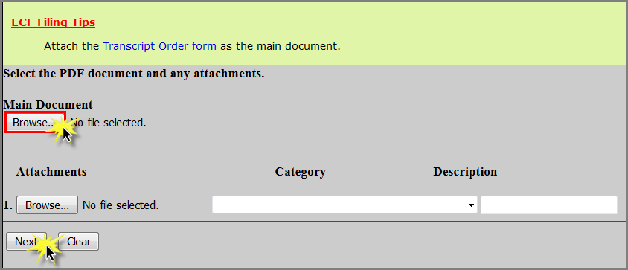

b. ECF Restriction Notice: This will be filed as a PUBLIC entry and a COURT-ONLY document. Click Next.
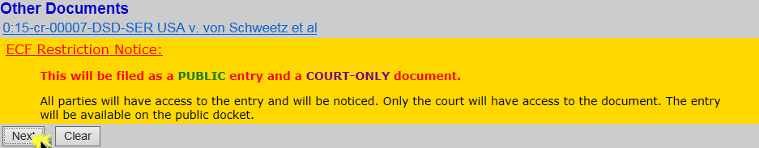
c. Select the Minute Entry for the hearing you are requesting a transcript of.
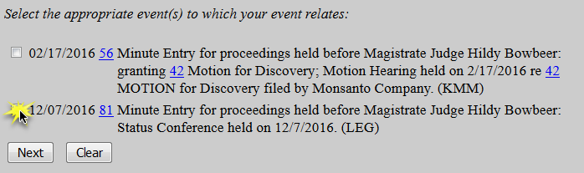

d. Use the drop down arrow to select the court reporter(s) and click Next.
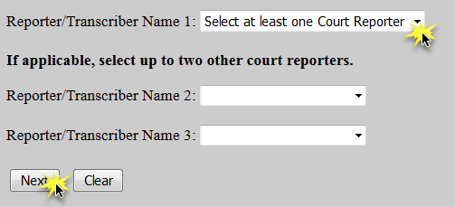

e. Select the delivery type and click Next.
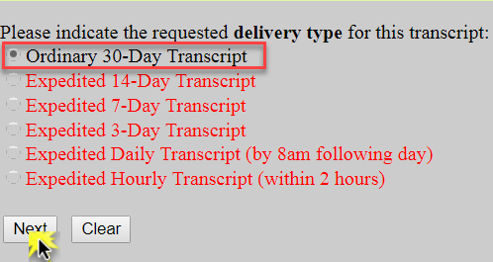

f. Click Next.
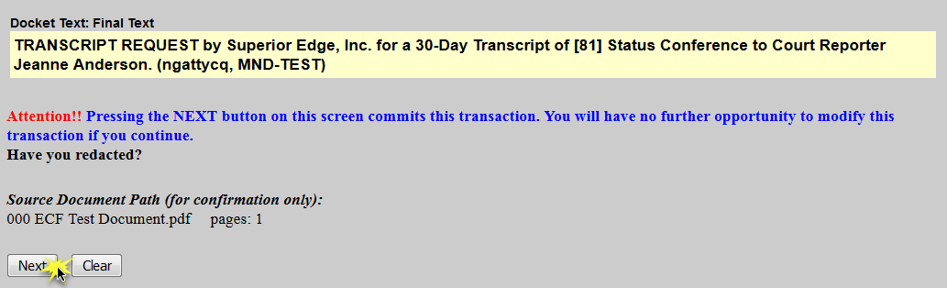
g. Ensure all information is accurate and click Next to finalize the request.

h. A Notice of Electronic Filing screen will appear to confirm the request was successful.
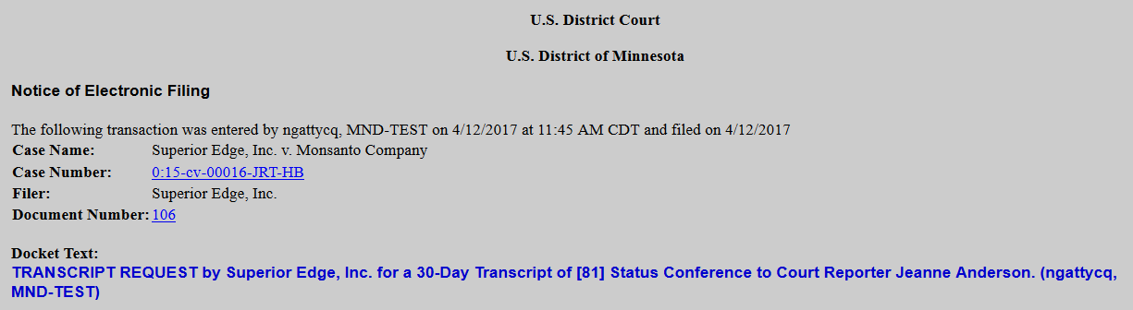

Copy of a Transcript:
- Click Browse to attach the completed Transcript Order Form as the Main Document and click Next.

b. ECF Restriction Notice: This will be filed as a PUBLIC entry and a COURT-ONLY document. Click Next.

c. Select whether or not a transcript has already been filed on the docket and click Next.
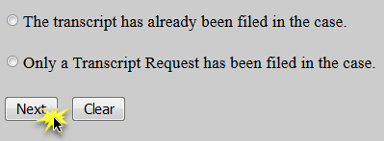

    - If the transcript has already been filed, select the desired transcript and click Next.
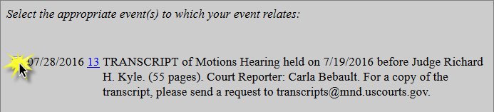

    - If the transcript has not yet been filed, select the Minute Entry for the hearing you are requesting a transcript of and click Next.

d. Use the drop down arrow to select the court reporter(s) and click Next.

e. Click Next.

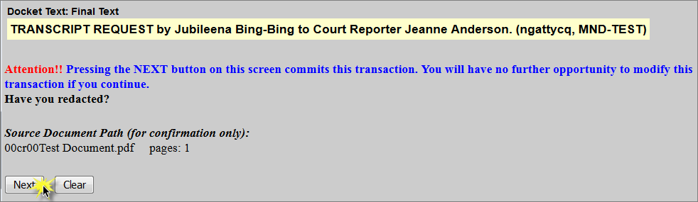
f. Ensure all information is accurate and click Next to finalize the request.

g. A Notice of Electronic Filing screen will appear to confirm the request was successful.
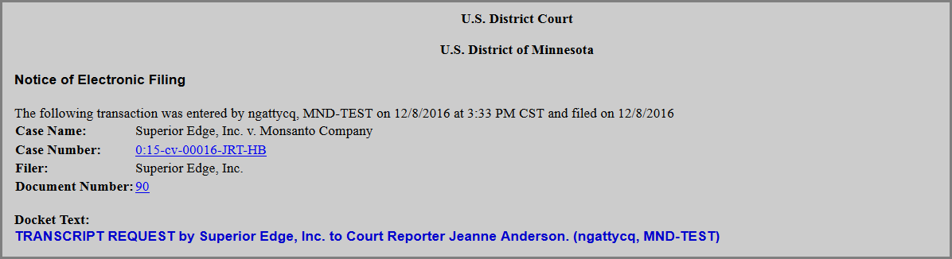

Advanced Request for Real-time, Hourly, or Daily Services:
- Click Browse to attach the completed Transcript Order Form as the Main Document and click Next.

b. ECF Restriction Notice: This will be filed as a PUBLIC entry and a COURT-ONLY document. Click Next.

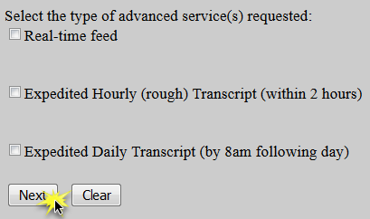
c. Select the type of advanced service(s) requested and click Next.

d. Use the drop down arrow to select the court reporter(s) and click Next.

e. Click Next.
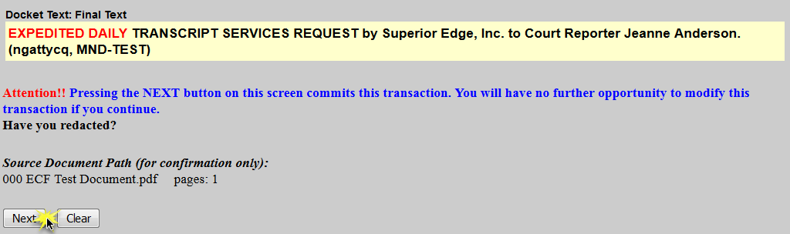
f. Ensure all information is accurate and click Next to finalize the request.

g. A Notice of Electronic Filing screen will appear to confirm the request was successful.
